PRESS RELEASE
FOR IMMEDIATE RELEASE 14/07/2025
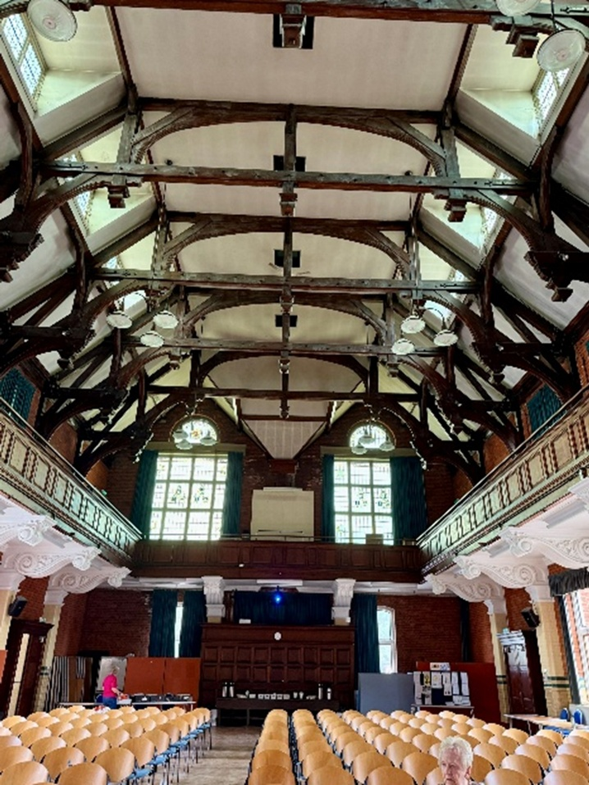
The people of Brentwood gear up to save Bishops Hill for community use.
Residents of Hutton, Shenfield and Brentwood have come together to save the historic Bishops Hill and its iconic Hall. Who hasn’t attended a performance or been invited to a celebration in the magnificent hall with its hammer beam roof?
For over a century, from when it was built in 1906, as part of the Poplars Residential School and Children’s Home Village for destitute children from Poplar, it has stood as a reminder of how young children with little prospect of a decent future can be provided with what they need to lead productive and fulfilling lives.
The building now faces an uncertain future; Essex County Council are moving adult education classes to other venues in the town. The council has no plans for the teaching areas freed up, now that proposals, to relocate council offices there, have fallen through. Ominously, Essex County Council have been unable to suggest what fate awaits the Hall.
Although the Residential School closed in 1982 there are plenty of residents that have family connections with ex pupils of the school. Even more have benefitted from the building’s later use as a base for Adult Education Classes or have enjoyed concerts by Brentwood Philharmonic Orchestra and Essex Chamber Orchestra.
Some users of the hall have set up the Bishops Hill Action Group (BHAG) to encourage Essex County Council to find a way to retain the Hall for community use. The petition to keep it open has already gained over 3,000 signatures, with local businesses lending their valuable support. It is also intended to get Bishops Hill designated as a Community Asset of Value, registered with Brentwood Council.

BHAG would also encourage everyone, who values this piece of our history, to contact their local councillors and urge them to add their weight to saving the hall for the community.
If anyone has not signed the petition or knows someone who hasn’t, then they can go to the on-line petition by using this QR code.
Time is short, Essex County Council has given notice that it is closing the site to the public from July 31st.
- Sign the petition.
- Contact your local councillor.
- Spread the word through your social media.
For media enquiries, interviews, or further information, please contact:
Clive or Sue Waddington
sue.waddington@yahoo.co.uk

